**מפרט ארכיטקטוני של המערכת**

Client Server Data

Get All  
Get By ID  
Post  
Put  
Delete

/members

MembersBL

Router

MongoDB

Mongoose

Main.js

React

/corona

Get Vaccine Stats

Get Active Patients Counts

CoronaBL

Router

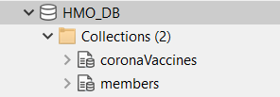**HMO DB**

**coronaVaccines –**

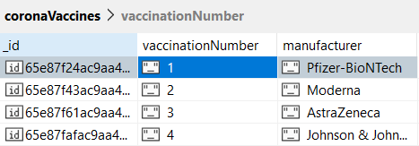

**members –**

const memberSchema = new mongoose.Schema({

    fName : String,

    lName : String,

    IDcard : String,

    address : {city : String, street : String, number : Number },

    dateOfBirth : {type: Date, required: false },

    phone : String,

    mobilePhone: String,

    coronaVaccines : { date1 : {type: Date, required: false }, date2 : {type: Date, required: false }, date3 : {type: Date, required: false }, date4 : {type: Date, required: false } },

    sickInCorona : { isPositive : Boolean, startDate: {type: Date, required: false }, endDate: {type: Date, required: false } },

    profileImage: String

})

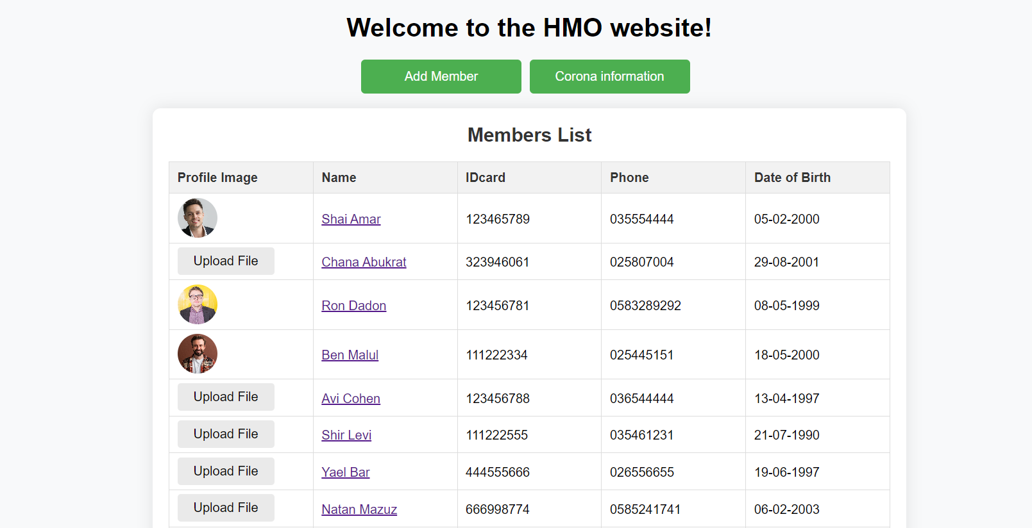**Client -**

